Where is Religion?: American Religion and the Politics of Space
College of Charleston, Spring 2017

FYSE 124 01-02 Prof. Shari Rabin
Tu/Th 12:15 PM-1:30 PM Jewish Studies Center 303
Jewish Studies Center 210 phone: 843-953-2036
Office Hours: Tu/Th 10am-12pm rabinsl@cofc.edu
(sign up at tinyurl.com/profrabin)
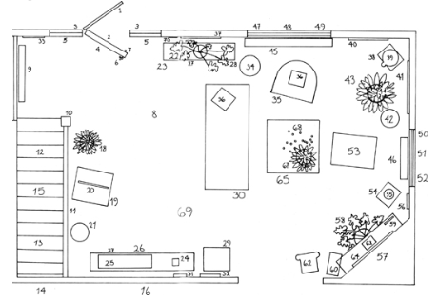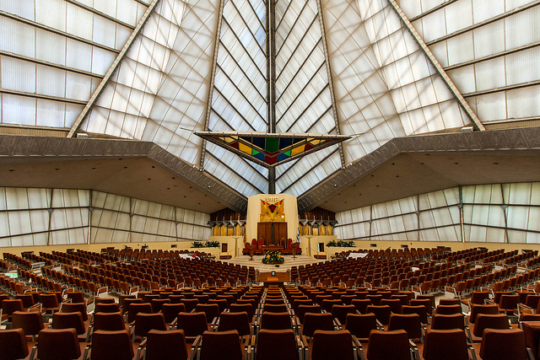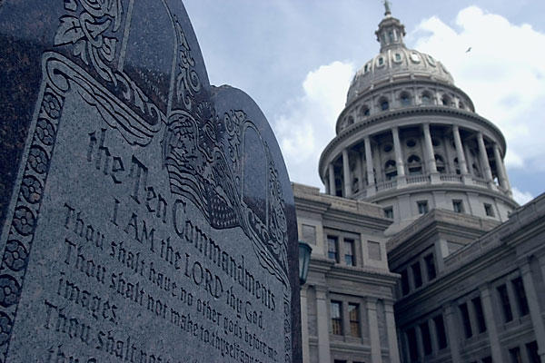
Everything happens somewhere. This course will analyze those "somewheres" within American religious history, from churches to prisons, mosques to mikvehs. We will use particular controversies – involving Judaism and other religious traditions – in order to understand how diverse religious communities have claimed space in America and how space has been significant to discussions of religion in American public life. Students will develop skills of critical analysis, learning to apply the frameworks of the course to a variety of contemporary examples.

Requirements:
Attendance: You will be excused for up to FOUR (4) absences during the semester. If you miss more than four classes, you should not expect to pass this course. I do not require you to submit paperwork when you do miss a class, but please be aware that I will enforce this policy strictly. (10%)

Participation: This class is a seminar, which means that you must do the reading and actively join in discussions and activities with good faith and generosity. I expect every student to make a meaningful contribution to discussion at least once per class. Laptops are only allowed if the professor explicitly tells you to bring it. Furthermore, if I see a phone out, I will confiscate it for the duration of that class session. (10%)

FYSS Attendance Policy: FYE Academic Course grade will decrease by (5% Points) based on attendance/participation and successful completion of the Synthesis Seminar assignments/modules

Office hours policy: You must attend my office hours once during the course of the semester, apart from the required theory presentation meeting.

Theory Presentation: Once during the course of the semester, you will give a presentation about the theory reading. You must describe the theorist (based on research) and teach your classmates about the reading. You must also pose a discussion question or facilitate an activity related to the reading. This presentation and discussion should last 20-25 minutes. You must meet with me briefly in office hours that week to discuss your presentation. (15%)

Reading Responses: Ten times during the semester, you must respond to the following three questions about the assigned section of the Albanese textbook:
-What kind of religion is being described in this section of the reading?
-Where does it take place? What spaces and places appear?
-What are your reactions? What did you find interesting? Do you have any questions? Does this connect to anything else you have seen, experienced, or learned about?
These responses must be submitted through OAKS by class time on the day the relevant Albanese reading is being discussed. Each response is worth 2% of your final grade. You will earn one point for answering the What and Where questions and one point for your reactions (20%).

Outside Activity: You must attend one on-campus event and write a one-page response connecting it to our course within one week of the event. I will post a list of suggested events in OAKS, but you may also get an event approved by me ahead of time. (5%)

Papers: There will be three short papers, one for each section of the course.
•The first paper will be a space ethnography (a description and analysis of human customs and practices). In three pages, use the theory of Wood and Beck, Mircea Eliade or Dolores Hayden to analyze one space from your everyday life. What is your space like? Who uses it? How might your theorist think about your chosen space? What would they point out about it? – Due September 14 (10%).
•The second paper will be an analysis of KKBE Synagogue. In three pages, you should write on one of the following two prompts:
•Abraham Joshua Heschel famously argues that Judaism has cathedrals of time, not of space. Using your observations from KKBE Synagogue, write a response to Heschel agreeing or disagreeing with his argument.
•Worship spaces can tell us a lot about the people who build and use them. Using your observations from KKBE Synagogue and the Albanese chapter on American Judaism, what can you tell about the values and identities of its congregants?
A mandatory outline will be due October 12. Following peer review, a final draft will be due October 19 (10%)
•For the third paper, find a contemporary news article related to a debate about religious spaces or about religion and public space. In four pages, describe the case and analyze it in light of at least one reading from the course. You will submit a paper proposal on November 21 (5%) – Final paper due date December 12 (15%)

A Note on Written Assignments: Papers must be written in Times New Roman, 12-point font, double-spaced with standard margins and using APA citation style. They should be submitted as Microsoft Word or PDF files to the designated OAKS Dropbox by class time. To see how many of you are reading the syllabus, if you see this, please email me a photo of an adorable puppy.

Required Text: Catherine Albanese, America: Religions and Religion, 5th edition

Grading Scale
A = 93-100
A- = 90-92
B+ = 87-89
B = 83-86
B- = 80-82
C+ = 77-79
C = 73-76
C- = 70-72
D+ = 67-69
D = 63-66
D- = 60-62
F = 0-60

Policies and Resources:

Honor Code
You are expected to abide by the Honor Code of the College of Charleston. The Honor Code of the College of Charleston forbids cheating, attempted cheating and plagiarism. A student found guilty of any of these offenses will receive a grade of “XF” in the course, and may be subject to additional penalties such as suspension or expulsion from the College, at the discretion of the Honor Board. See the College of Charleston Student Handbook, for definitions of these offenses (www.cofc.edu/generaldocuments/handbook.pdf).

Disability Accommodations
If you have a documented disability and have been approved to receive accommodations through the Center for Disability Services / SNAP, please come and discuss this with me during my office hours.

Writing Lab
I encourage you to take advantage of the Writing Lab in the Center for Student Learning (Addlestone Library, first floor). Trained writing consultants can help with writing for all courses; they offer one-to-one consultations that address everything from brainstorming and developing ideas to crafting strong sentences and documenting sources. For more information, please call 843.953.5635 or visit http://csl.cofc.edu/labs/writing-lab/.

Learning Outcomes
By the completion of the First-Year Experience, a student will be able to...
•Identify and use the appropriate academic resources and student support services at College of Charleston. These would include the Addleston library, information technology, the Center for Student Learning, the Career Center, and other appropriate academic resources, student support services, and cultural resources.
•Use appropriate tools and search strategies for identifying particular types of information specific to the discipline
•Evaluate the relevance, quality, and appropriateness of different sources of information
•Recognize and classify the information contained within a bibliographic citation
•Access and use information ethically and legally
•Use appropriate critical thinking skills and problem-solving techniques in appropriate disciplinary contexts
•Make connections across disciplines and/or relevant experiences

Week 1 – What is Religion in America?
Tuesday, August 22

Thursday, August 24
Catherine Albanese, “Introduction,” America: Religions and Religion, 1-13
Theory: Wood and Beck, “Home Rules”

Week 2 - Church
Tuesday, August 29
Albanese, “Word from the Beginning: American Protestant Origins and the Liberal Tradition,” 86-91.

Thursday, August 31
Theory: Mircea Eliade, “The World, the City, the House,” in Experience of the Sacred: Readings in the Phenomenology of Religion, 188-199.

Week 3 – Mosque
Tuesday, September 5
Albanese, “East is West: Eastern Peoples and Eastern Religions,” 214-220

Thursday, September 7
Theory: Dolores Hayden, “Urban Landscape History: The Sense of Place and the Politics of Space” (1995)

Week 4 – Synagogue
Tuesday, September 12
Albanese, “Israel in a Promised Land: Jewish Religion and Peoplehood,” and “The Jewish ‘Conspiracy’” 42-46, 307-9

Thursday, September 14– Space Ethnography Paper Due - KKBE Field Trip

Week 5 - KKBE
Tuesday, September 19
Theory: Abraham Joshua Heschel, “Architecture of Time,” in The Sabbath, 2-11.

Thursday, September 21 – No Class – Rosh Hashannah

Week 6 – Mikvah
Tuesday, September 26
Albanese, “Israel in a Promised Land: Jewish Religion and Peoplehood,” 46-50

Thursday, September 28
Theory: Leslie Kanes Weisman, “Women’s Environmental Rights: A Manifesto,” 1-5.

Week 7 - Sukkah
Tuesday, October 3– Field Trip to Sukkah
Albanese, “Israel in a Promised Land: Jewish Religion and Peoplehood,” 50-55

Thursday, October 5
Theory: Victor Turner, “Liminality and Communitas,” Performance Studies Reader, 79-87.

Week 8 – Eruv
Tuesday, October 10
Albanese, “Israel in a Promised Land: Jewish Religion and Peoplehood,” 55-61

Thursday, October 12– Jewish Space Draft Due
Theory: Thomas Tweed, “Space,” Material Religion, 116-123

Week 9 – Land
Tuesday, October 17
Albanese, “Original Manyness: Tradition and Change among Native Americans,” 21-26

Thursday, October 19 – Jewish Space Paper Due

Week 10 – Street
Tuesday, October 24
Albanese, “Restoring an Ancient Future: The Protestant Churches and the Mission Mind,” 113-19

Wednesday, October 25, 6:30pm, Arnold Hall - Jewish Studies Meet-to-Eat

Thursday, October 26
Theory: Michel De Certeau, "Walking in the City," The Practice of Everyday Life, 91-110.

Week 11 – School
Tuesday, October 31
Albanese, “Public Protestantism: Historical Dominance and the One Religion of the United States,” 275-8; “Many Centers Meeting,” 302-7

Thursday, November 2 – No Class - Conference

Week 12 – Prison
Tuesday, November 7
Albanese, “The Protestant Code,” 278-81; “The Protestant Creed,” 282-4

Thursday, November 9
Theory: Michel Foucault, “Complete and Austere Institutions,” The Foucault Reader, 214-226

Week 13 – Cemetery
Tuesday, November 13
Albanese, “Homesteads of the Mind: Belief and Practice in Metaphysics,” 183-5, 189-93

Thursday, November 16
Theory: Michel Foucault, “Of Other Spaces,” Diacritics (Spring 1986), 22-27.

Week 14
Tuesday, November 21– No Class - News Article Drafts Due

Thanksgiving Break

Week 15 – Internet
Tuesday, November 28
Albanese, “American Codes of Living,” 295-9

Thursday, November 30
Theory: Benjamin, “The Work of Art in the Age of Mechanical Reproduction”

