Modern Jewish History
College of Charleston
Fall 2016

Jewish Studies 215 01/02 Prof. Shari Rabin
MWF 10:00-10:50 AM/11:00-11:50 AM Jewish Studies Center 222
Jewish Studies Center 100 phone: 843-953-2036
Office Hours: MW, 9-10am, 3:30-4:30pm rabinsl@cofc.edu
or by appointment

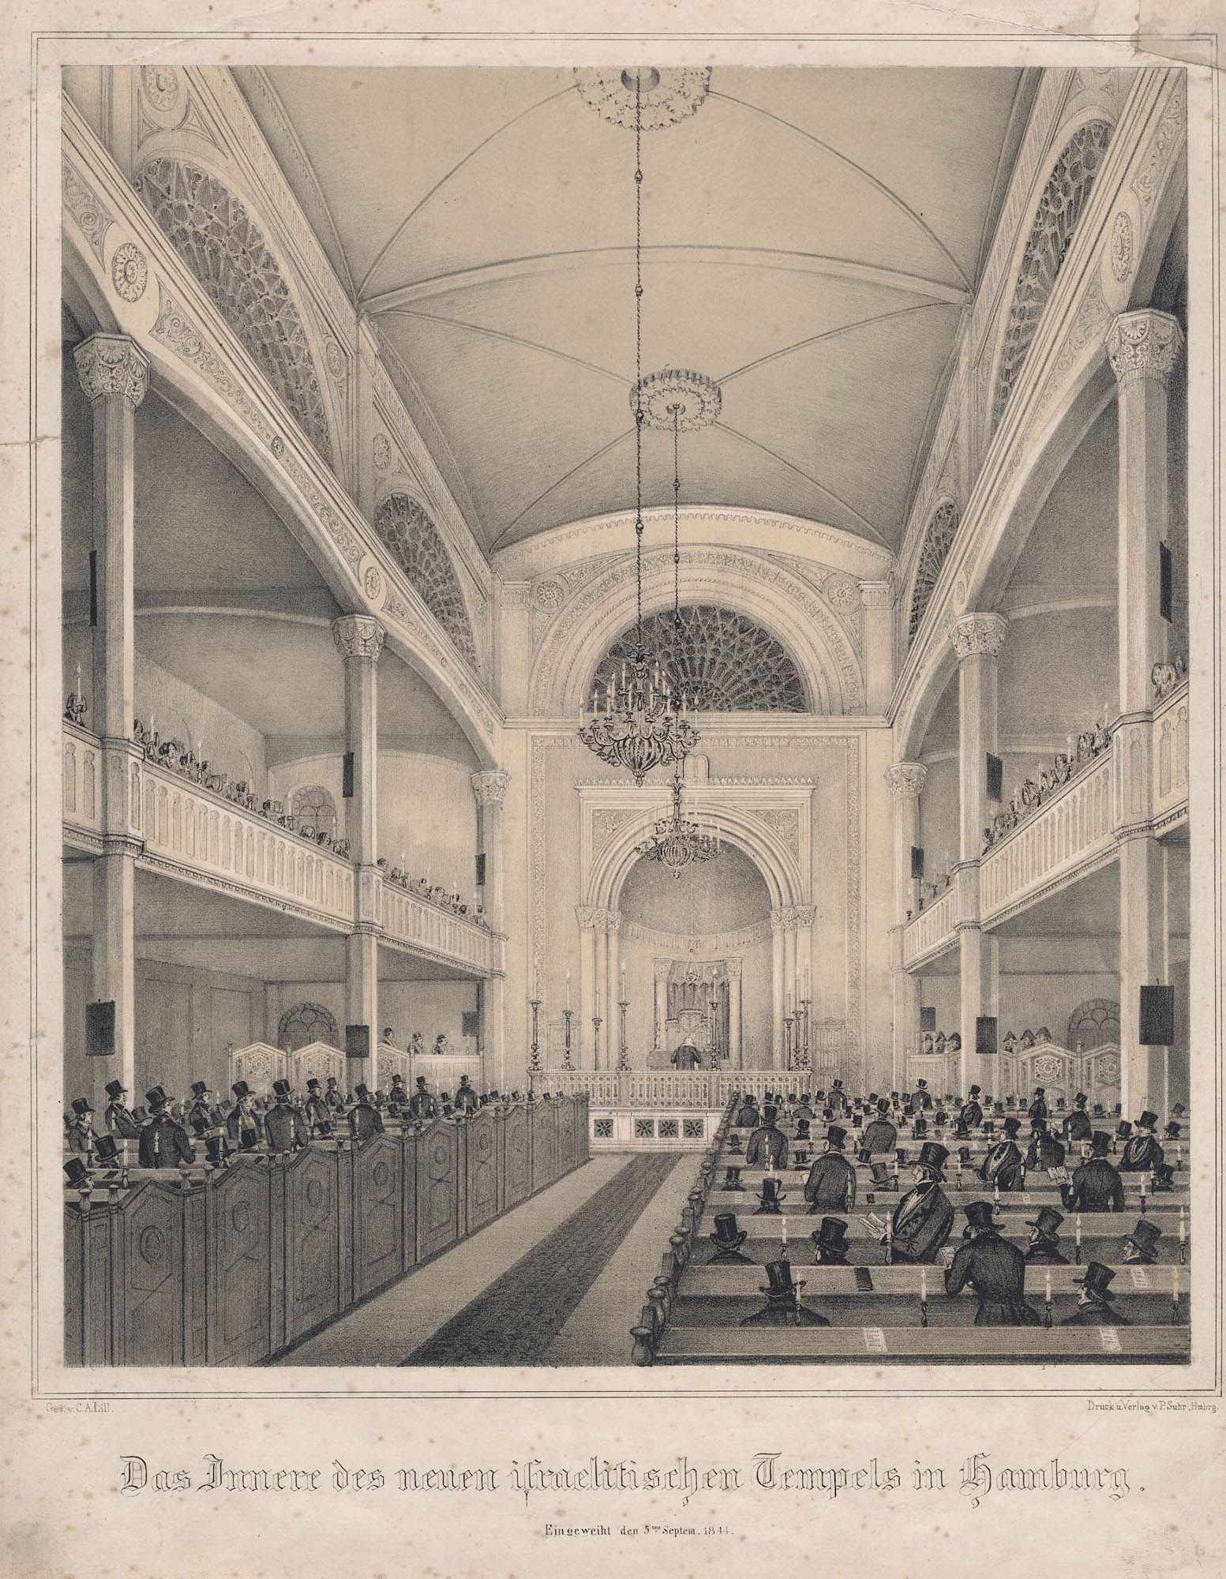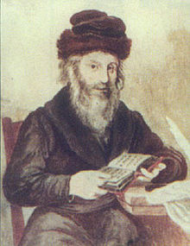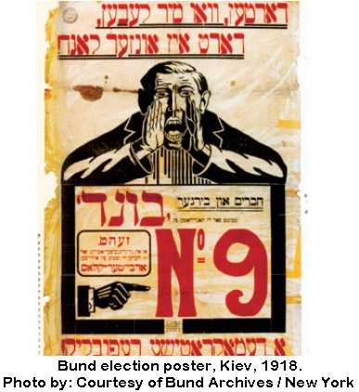

This course explores diverse expressions of Jewish life and thought in the modern period, from roughly 1700 to the present. We encounter a wide range of Jews, from the humble and ordinary to the very powerful and influential in order to understand who the Jews are and how they have contributed to and been transformed by the forces of modernity, including the nation-state, global capitalism, war, and migration. We explore how Jews came to understand themselves politically and religiously in a range of times and places.

Students first and foremost learn some of the key themes and events of modern Jewish history. Students also acquire tools of critical thinking, reading, and writing by engaging with diverse sources and participating in active discussion. For the most part, Mondays and Wednesdays are lecture-based, with Fridays reserved for discussion and activities.

Prerequisites: None

Learning Outcomes:
Students demonstrate knowledge of history and awareness of the historical experience.
Students situate primary historical records in their context and use sources to construct historical arguments.
Students will use models and theories to analyze a cross-cultural issue.
These outcomes will be assessed on the final memoir introduction assignment.

Policies and Resources:

Honor Code
You are expected to abide by the Honor Code of the College of Charleston. The Honor Code of the College of Charleston forbids cheating, attempted cheating and plagiarism. A student found guilty of any of these offenses will receive a grade of “XF” in the course, and may be subject to additional penalties such as suspension or expulsion from the College, at the discretion of the Honor Board. See the College of Charleston Student Handbook, for definitions of these offenses (www.cofc.edu/generaldocuments/handbook.pdf).

Disability Accommodations
If you have a documented disability and have been approved to receive accommodations through the Center for Disability Services / SNAP, please come and discuss this with me during my office hours.

Center for Student Learning
I encourage you to utilize the Center for Student Learning’s (CSL) academic support services for assistance in study strategies and course content. They offer tutoring, Supplemental Instruction, study skills appointments, and workshops. Students of all abilities have become more successful using these programs throughout their academic career and the services are available to you at no additional cost. For more information regarding these services please visit the CSL website at http://csl.cofc.edu or call (843)953-5635.

Required Texts
- Liora Batnitzky, How Judaism Became a Religion: An Introduction to Modern Jewish Thought
- One of the three texts for the Memoirs assignments:
  - Yossi Klein Halevi, Memoirs of a Jewish Extremist: The Story of a Transformation
  - Lucette Lagnado, The Man in the White Sharkskin Suit: A Jewish Family’s Exodus from Old Cairo to the New World
  - Gary Shteyngart, Little Failure: A Memoir
- All other texts will be posted on OAKS.

Requirements:

Participation (10%)
You are expected to attend class and to actively participate in discussions and activities. Laptops are only allowed in class on Fridays (note: I will post PowerPoints on OAKS for your use, but they do not substitute for active note taking). I do not require documentation for absences, but if you have more than six (6) absences you should not expect to pass the class. You must sign in on the class attendance sheet every day.

A Note on Assignments: All assignments must be written in Times New Roman, 12-point font, double-spaced with standard margins and using APA citation style. They should be submitted as Microsoft Word files to the designated OAKS Dropbox by 12pm on the due date.

Late Policy
You will lose 5 percentage points per day that an assignment is late.

Midterm Reflection (10%)
You will write a 2-3 page reflection on Solomon Maimon’s memoir, due September 30.

Reading Responses (30%)
You will be required to submit 7 response papers throughout the semester of 1-2 pages (PLUS mandatory handouts in weeks 5, 7, and 9). This means you can skip four weeks of reading responses and still fulfill the requirement. These should respond to the question posed in the syllabus relating to that week’s topic, with specific reference to both primary and secondary sources. You should also include as part of your response a question about aspects of the reading – either something that confused you or something that interested you. Each will be worth 3 points, one point for showing that you have completed the readings, and two points on the content of your response, including your questions for further discussion. They are due in the proper OAKS Dropbox on Friday (or the last day of class that week).

Memoir Assignments (50%)
At the beginning of the semester you will be assigned to read one of three modern Jewish memoirs. You will receive more details later, but for now, know that you will have the following responsibilities related to this book:
•You will turn in a 2-3 page Blog Post about your memoir, due November 2 (15%).
•On November 28, you will participate in a class-length book discussion (5%)
•You will write a 5-7 page Memoir Introduction, due December 12 (30%)

Extra Credit:
You can replace one reading responses by participating in each of these class tours:
KKBE Tour – Date TBD
Zionismus Exhibit – Date TBD

You can add up to five percentage points to your midterm paper grade once by attending a Jewish studies film and writing a 1-2 page summary and response:
Yidl Mitn Fidl – August 29 (1936, 92min) – A love story about a female musician forced to pose as a man.
Tevye – September 5 (1939, 93min) – The original “Fiddler on the Roof.”
Unzere Kinder – November 21 (1948, 68min) - Poland’s last Yiddish feature film, performed to Holocaust survivor children.
Amerikaner Shadchan – November 28 (American Matchmaker, 1940, 87min) – A romantic comedy about an eligible bachelor.
Schedule of Classes

PART I: THE MODERN AGE

Week 1 - The Origins of Modernity
W Aug 24 Lecture
F Aug 26 Lecture

Secondary Reading:
- Batnitzky, Introduction
Primary Readings:
- Glikl of Hameln (1690s), 483-5 and excerpts
Question:
What was it like to be Jewish in early modern Europe?

Week 2 – Emancipation and Enlightenment in the West
M Aug 29 Lecture
W Aug 31 Lecture
F Sep 2 Discussion

Secondary Readings:
- Batnitzky, Ch. 1
Primary Readings:
- Solomon Maimon, “My Emergence from Talmudic Darkness,” (1793), 796-799
- Count Molé, “Napoleon’s Instructions to the Assembly of Jewish Notables,” (1806), 149-50
Questions:
How did the Enlightenment change the relationship between Jews and the societies in which they lived?

Week 3 – Emancipation and Enlightenment in the West II
M Sep 5 Lecture
W Sep 7 Lecture
F Sep 9 Discussion

Secondary Reading:
- Batnitzky, Ch. 2
Primary Readings:
- Moses Sofer, “A Reply Concerning the Question of Reform” (1819), 169-173
- The Reform Rabbinical Conference at Frankfurt, “The Question of Messianism,” (1845), 207-9
Questions:
Why did history become an area of interest and concern in nineteenth-century Germany? How did different Jews understand its role?
Week 4 – Modernity in Eastern Europe
M Sep 12 Lecture
W Sep 14 Lecture
F Sep 16 Discussion

Secondary Reading:
- Batnitzky, Ch. 6
Primary Readings:
- Solomon Maimon, “The New Hasidim” (1793), 365-8
- Rabbi David Moses Joseph of Krynki, “The Volozhin Yeshiva” (1909), 372-3
Questions:
How did Eastern European Jews relate to tradition?

Week 5 – Modernity in Eastern Europe II
M Sep 19 Lecture
W Sep 21 Lecture
F Sep 23 Discussion

Secondary Reading:
- Batnitzky, Ch. 7
- Sarah Ponichtera, “The Problem of Materiality in Yiddish Translation,” In Geveb: A Journal of Yiddish Studies, May 4, 2016
Primary Readings:
- I.L. Peretz, “If Not Higher” (1900), 231-3
Questions: Mandatory Handout (Due by class-time Wednesday)

Week 6 – The Ottoman Empire and Middle Eastern Jewry
M Sep 26 Lecture
W Sep 28 Lecture
F Sep 30 Discussion (MIDTERM REFLECTION DUE)

Secondary Reading:
- Aaron Rodrige, “The Ottoman Diaspora: The Rise and Fall of Ladino Literary Culture,” Cultures of the Jews, 863-886
Primary Readings:
- Excerpts from A Jewish Voice from Ottoman Salonica, The Ladino Memoir of Sa'adi Besalel a-Levi Aron Rodrigue
- Alliance Israélite Universelle, “Our First Thirty-Five Years” (1895), 293-6
Questions: What was the role of Ladino in Sephardic Jewish life? Compare and contrast it to Yiddish.

Extra Credit KKBE Tour, 90 Hasell Street – Time TBD

Week 7 – The Anglophone Jewish Diaspora
M Oct 3 NO CLASS – ROSH HASHANNAH
W Oct 5 Lecture
F Oct 7 Lecture

Secondary Reading:
- Adam Mendelsohn, “Tongue Ties: The Emergence of the Anglophone Jewish Diaspora in the mid-Nineteenth Century,” American Jewish History, June 2007, pp. 177-209
Primary Readings:
- “Memorial to….KKBE of Charleston” (1824), 79-80
- British Parliament, “The Jewish Relief Act” (1858), 174-5
Questions: Mandatory Handout (Due by class-time Friday)

PART II: THE TWENTIETH CENTURY AND BEYOND

Week 8 – American Jewish Life
M Oct 10 Lecture
W Oct 12 NO CLASS – YOM KIPPUR
F Oct 14 Discussion

Secondary Reading:
- Batnitzky, Ch. 9
Primary Readings:
- The Jazz Singer (1927) – Screening October 9, 5pm (Arnold Hall)
- Excerpts from A Bintel Brief
Questions: How did American Jewish life change from the nineteenth century to the early 20th century? Give at least two examples.

Week 9 – European Problems and Solutions
M Oct 17 Lecture
W Oct 19 Lecture
F Oct 21 Discussion

Secondary Reading:
- Batnitzky, Ch. 8
Primary Readings:
- To be assigned on the previous Friday
Questions: Mandatory Handout (Due by class-time Wednesday)

Week 10 – War, Revolution, and their Aftermath
M Oct 24 Lecture
W Oct 26 Lecture
F Oct 28 Discussion

Secondary Reading:
- Batnitzky, Ch. 4
Primary Readings:
- Borukh Yismakh, “Sports Clubs and Self-Defense [in Wyszkow, Poland],” 88-91
- Yevsektsiya, “The Liquidation of Bourgeois Jewish Institutions” (1918), 412-4
Questions: How and why did European Jewish life change after World War I? Was it for better or worse?

Extra Credit Zionismus Tour, Addlestone Library – Time TBD

Week 11 – World War II and The Holocaust
M Oct 31 Lecture
W Nov 2 Lecture
F Nov 4 Discussion (BLOG POST DUE)

Secondary Reading:
- Batnitzky, Ch. 5
Primary Readings:
- Adolf Hitler, “Mein Kampf” (1923), 717-9
- Chaim A. Kaplan, “A Warsaw Ghetto Diary,” (1940), 666-8
Questions: What would you argue are the most important aspects to understanding the Holocaust?

Week 12 – Post-Holocaust Jewish Life
M Nov 7 NO CLASS – FALL BREAK
W Nov 9 Lecture
F Nov 11 Discussion

Secondary Reading:
- Batnitzky, Chapter 3
Primary Readings:
- “Chart, World Jewry Before and After the War, 1939-1945,” 274
- David Hartman, “Auschwitz or Sinai?” (1982)
Questions: How did Jewish life and thought change after the Holocaust?

Week 13 – Israel and the World
M Nov 14 Lecture
W Nov 16 Lecture
F Nov 18 Discussion

Secondary Reading:
- Eli Yassaf, “The ‘Other’ Israel: Folk Cultures in the Modern State of Israel,” 1063-91
Primary Readings:
- “Blaustein and Ben-Gurion Agreement” (1950), 322-6
- Excerpts from The Jewish Catalog (1973), 87-90
Questions: How would you describe relations between Israel and other Jewish communities around the world?

Week 14
M Nov 21 NO CLASS - CONFERENCE

W Nov 23 NO CLASS – THANKSGIVING

F Nov 25 NO CLASS - THANKSGIVING

Week 15 – Book Discussion and Contemporary Jewish Life
M Nov 28 Book Discussion
W Nov 30 Lecture
F Dec 2 Discussion

Secondary Reading:
- Batnitzky, Conclusion
Primary Readings:
- Jeffrey Goldberg, “Is it Time for the Jews to Leave Europe?” The Atlantic, April 2015
- http://www.pewforum.org/2013/10/01/jewish-american-beliefs-attitudes-culture-survey/
Questions: Do you see the future of the Jews as hopeful?

Week 16 – Special Topic and Conclusion
M Dec 5 Lecture

December 12 – Memoir Introduction Due

